

*Technology in Cancer Research and Treatment ISSN 1533-0346*

*Volume 13, Number 4, August 2014*

*© Adenine Press (2014)*

**A Review on Ultrasound-based Thyroid Cancer Tissue Characterization and Automated**

**Classification**

[www.tcrt.org](http://www.tcrt.org/)

DOI: 10.7785/tcrt.2012.500381

In this paper, we review the different studies that developed Computer Aided Diagnostic (CAD) for automated classification of thyroid cancer into benign and malignant types. Spe- cifically, we discuss the different types of features that are used to study and analyze the differences between benign and malignant thyroid nodules. These features can be broadly categorized into (a) the sonographic features from the ultrasound images, and (b) the non- clinical features extracted from the ultrasound images using statistical and data mining tech- niques. We also present a brief description of the commonly used classifiers in ultrasound based CAD systems. We then review the studies that used features based on the ultrasound images for thyroid nodule classification and highlight the limitations of such studies. We also discuss and review the techniques used in studies that used the non-clinical features for thy- roid nodule classification and report the classification accuracies obtained in these studies.

Key words: Thyroid lesion; Computer aided diagnosis; High resolution ultrasound; Contrast enhanced ultrasound; Texture.

# *Introduction*

About 50% of the adults have thyroid nodules, out of which only 5% turn out to be malignant. It is estimated that in 2013, 60,220 new thyroid cancer cases will occur and the deaths related to thyroid cancer will be about 1,850 (1). It was observed

**U. Rajendra Acharya, Ph.D.,**

**D.Eng.1,2**

**G. Swapna, M.Eng.3**

**S. Vinitha Sree, Ph.D.4 Filippo Molinari, Ph.D.5* Savita Gupta, Ph.D.6 Ricardo H. Bardales, M.D.7 Agnieszka Witkowska, M.D.,**

**Ph.D.8**

**Jasjit S. Suri, M.S., Ph.D., M.B.A., Fellow AIMBE9**

1Department of Electronics and Communication Engineering, Ngee Ann Polytechnic, Singapore 599489 2Department of Biomedical Engineering, Faculty of Engineering, University of Malaya, 50603 Kuala Lumpur, Malaysia

3Department of Applied Electronics and Instrumentation, Government Engineering

College, Kozhikode, Kerala 673005, India

7Outpatient Pathology Associates, Sacramento, CA 95816

8Department of Internal Medicine, Diabetology and Nephrology, Medical University of Silesia, Zabrze, Poland

9ThyroScan Division, Global Biomedical Technologies, Inc., CA, USA; AtheroPoint(TM), LLC, Roseville, CA, USA; Electrical Engineering Department, Idaho State University (Affl.), ID, USA

4Global Biomedical Technologies Inc., CA, USA

5Biolab, Department of Electronics and Telecommunications, Politecnico di Torino, Torino, Italy

6Department of Computer Science and

Engineering, University Institute of

**Abbreviations:** ATC: Anaplastic Thyroid Cancer; CAD: Computer Aided Diagnostic; CEUS: Contrast Enhanced Ultrasound; CT: Computed Tomography; DT: Decision Tree; FD: Fractal Dimension; FIS: Fuzzy Inference System; FNAB: Fine-needle Aspiration Biopsy; FSD: Fourier Spectrum Descriptor; FTC: Follicular Thyroid Cancer; GLCM: Gray Level Co-occurrence Matrix; GMM: Gaussian Mixture Model; HCC: Hurthle Cell Carcinoma; HCN: Hurthle Cell Neoplasms; HRUS: High Resolution Ultrasound; K-NN: K-Nearest Neighbor; LBP: Local Binary Pattern; LTE: Laws Texture Energy; MRI: Magnetic Resonance Imaging; MTC: Medullary Thyroid Cancer; NBC: Naives Bayes Classifier; PNN: Probabilistic Neural Network; PPV: Positive Predictive Value; PTC: Papillary Thyroid Cancer; SUV: Standardized Uptake Value; SVM: Support Vector Machine; TSH: Thyroid-stimulating Hormone; US: Ultrasound.

Engineering and Technology (UIET), Panjab University, Chandigarh, India

*Corresponding author: Prof. Filippo Molinari, Ph.D. Phone: 139 (0)11 090 4135

Fax: 139 (0)11 090 4217

E-mail: [filippo.molinari@polito.it](mailto:filippo.molinari@polito.it)

**289**

that the incidence of thyroid cancer has increased 2.4 times over the last 30 years (2-4). This increase is among the larg- est increase that has happened in any type of cancer (5). The possibility of incidence of thyroid cancer increases with age (more likely for people with age more than 50 years). Women are twice more likely to be affected by thyroid cancer than men. But once affected, its prognosis is worse for men com- pared to women. Generally, thyroid cancer manifests as a painless nodule in the thyroid region of the neck. Other possi- ble signs are enlarged lymph node, pain in the anterior region of the neck and voice change due to involvement of recur- rent laryngeal nerve. Tests for thyroid nodule diagnosis clas- sify nodules into two main categories: benign and malignant. Colloid nodules, benign cysts, macrofollicular adenoma, and multinodular goiter are benign lesions. Surgical treatment of the nodule is not required in this case unless the nodule enlarges or causes some difficulties (6).

Thyroid malignancies can occur in different cell types of thyroid gland like thyroid follicular cells, calcitonin- producing C cells, lymphocytes, stromal and vascular ele- ments. Thyroid cancers can be classified into the following important categories: Papillary Thyroid Cancer (PTC), Fol- licular Thyroid Cancer (FTC), Medullary Thyroid Cancer (MTC) and Anaplastic (or undifferentiated) Thyroid Cancer (ATC) based on their histopathological characteristics. The prognosis of thyroid cancer depends on the type of cancer and the stage of the cancer at the time of diagnosis. PTC is characterized by histological and cytological features such as the presence of psammoma bodies, papillary structures and irregularities in the nuclear contour, and size and the pres- ence of deep nuclear grooves (6). FTC is commonly seen in iodine-deficient regions accounting for 15% of all thyroid cancers. It is more aggressive compared to PTC. Hurthle Cell Carcinoma (HCC) is a subcategory of FTC. In HCC, oncocytes rich in mitochondria are present, which makes HCCs appear as brown in their cut surface (6). ATC, which accounts for less than 5% of thyroid cancer, is difficult to cure. Most of the patients usually die within six months of detection of ATC since it is not responsive to treatment. MTC, which is a cancer of the parafollicular cell, accounts for 2-5% of thyroid cancers.

The success of the treatment is higher when cancer is diagnosed at an early stage. If the treatment does not give desirable results, the cancerous part must be removed (thy- roidectomy) before the cancer spreads. The sensitive methods to detect thyroid nodules are Fine-Needle Aspiration Biopsy (FNAB), Computed Tomography (CT), Magnetic Resonance Imaging (MRI), Ultrasound (US) imaging, elastography and pathologic studies. FNAB is the gold standard for detecting malignancy in thyroid nodule (7). The initial objective of the tests is to detect whether any nodules are present in thyroid.

The next task is to check whether the detected nodule is malig- nant or not. Early detection of thyroid cancer can reduce the possibility of mortality (8). Given below is a brief descrip- tion of the two most commonly used detection modalities, namely, FNAB and Ultrasonography.

*Fine-needle Aspiration Biopsy (FNAB)*

FNAB uses aspiration to obtain cells or fluid from a thyroid nodule mass. Histological examination of tissue specimens are conducted to obtain cytological results. The cytologi- cal diagnoses of FNAB can be classified into the following classes: benign (negative for cancer), suspicious for thyroid cancer, indeterminate (follicular or Hurthle cell neoplasm), malignant (positive for cancer) or unsatisfactory (non-diag- nostic) (9). Gul *et al*. (10) found that FNAB has very good capability in evaluating thyroid nodules. They reported sen- sitivity, specificity, Positive Predictive Value (PPV), and accuracy of FNAB to be 89.16%, 98.77%, 96.10%, and 96.32%, respectively. Colloidal goiter, lymphocytic thyroid- itis, Hashimoto thyroiditis, follicular adenoma, Hurthle cell adenoma, nodular goiter, and nodular hyperplasia fall under benign cytology category. Suspicious category comprises of cases of follicular lesion or neoplasm, Hurthle cell lesion or neoplasm, and lesion suspicious for papillary carcinoma. Papillary carcinoma, follicular carcinoma, Hurthle cell carci- noma, medullary carcinoma, and anaplastic carcinoma come under the class of malignant cytology (10). Suspicious and indeterminate cases have only subtle differences. Indeter- minate category implies that the observed cytology is not typical, but a definite diagnosis is not possible cytologically. Generally, 20% of the indeterminate cases turn out to be malignant. Aspirates with an insufficient number of cells for diagnosis fall under the non-diagnostic group (6). In general, US guided FNA is conducted if the nodule size is smaller than 1.5 cm (6).

When FNA biopsy of thyroid nodules is conducted, approxi- mately 70% (50% to 90%) are, in general, observed to be benign, approximately 4% (1% to 10%) malignant or suspi- cious for malignancy, and 10% (5% to 20%) turn out to be non-diagnostic or yielding insufficient material for diagnosis.

For the following two reasons, it is unnecessary to take an invasive and labor intensive test like FNA to initially detect whether a thyroid nodule is malignant or not: (1) only a small percent of the total thyroid nodules have the probability to be malignant. In other words, only 9 to 13% of the thyroid nodules tested using FNAB are labeled as malignant, and

1. the occurrence of indeterminate results for the fine needle aspirations because of the low cellularity, small size and cys- tic nature of nodules or due to inexperience of the operator performing the FNA test.

*Ultrasonography*

This is a non-invasive and inexpensive imaging technique, which provides the image depicting the intranodular architec- ture of thyroid gland. It does not have any radioactive hazards and it has a short acquisition time. It is also less expensive compared to other imaging techniques like CT and MRI. Technological advancement has led to the development of high-frequency probes. Using these probes, US images with very high resolution can be obtained (5). Because of its superficial location, the thyroid gland is ideally suited for high-frequency sonography for the detection of non-palpable nodules of thyroid cancer of 2-3 mm size using 7-13 MHz transducer (11). US images of benign and malignant thyroid nodules have distinguishable sonographic characteristics. Benign nodules show very little internal flow compared to that of malignant nodules (11). Malignant nodules show the presence of a peripheral ring, while it can be present or absent in a benign module (11). There are two popular US imag- ing techniques for thyroid imaging. They are High Resolu- tion Ultrasound (HRUS) and Contrast Enhanced Ultrasound (CEUS). More about these techniques are presented in the following section.

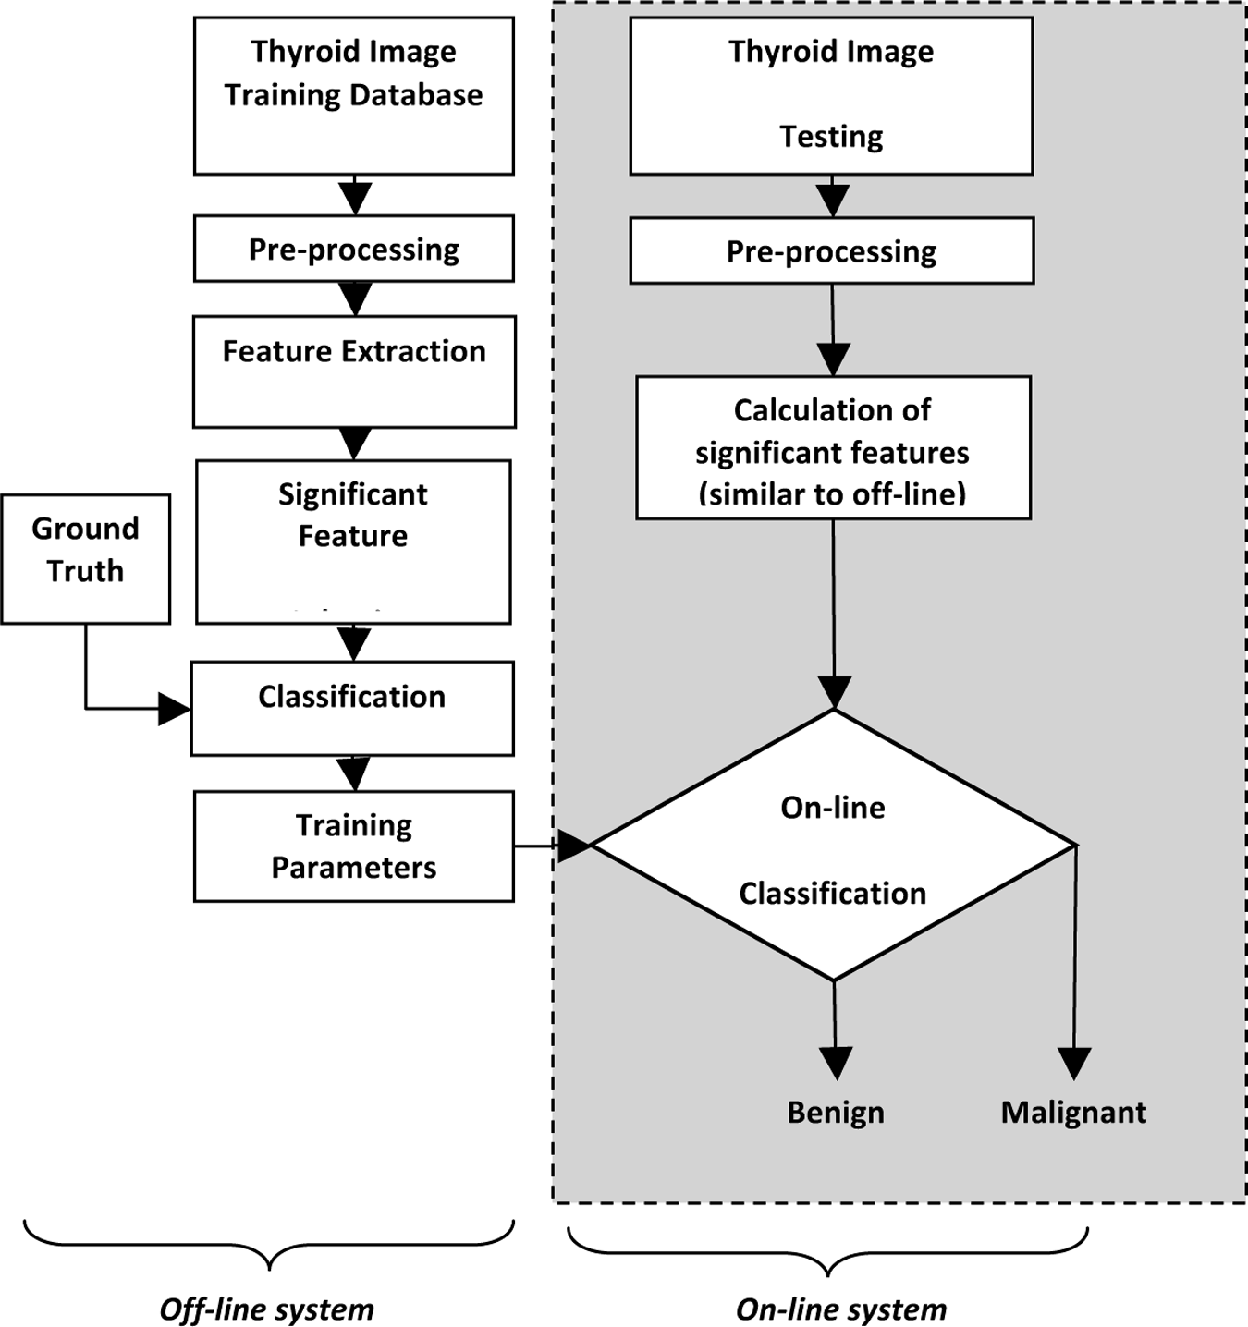Ultrasonography has some limitations. The reliability of diagnosis depends on factors such as quality of images and the expertise of the ultrasonographers who interpret the images. It is likely for US images to be easily affected by echo perturbations and speckle noise, which interfere with the correct diagnosis. Another point is that different types of benign and malignant nodules have different characteris- tics on an ultrasound image. Therefore, accu- rate visual interpretation of the class of these images can only be done by ultrasonographers with lot of experience and training. Other- wise, it results in subjective interpretations and inter-observer variabilities. Such limita- tions have led to extensive research in devel- oping automated efficient US image analysis techniques called Computer Aided Diagnostic (CAD) systems so as to obtain accurate, repro- ducible and more objective diagnosis results.

and HRUS images of benign and malignant nodules by appropriate statistical and data mining techniques and these features are used in classifiers to achieve benign-malignant classification of thyroid nodules. For ease of reference, we will refer to these features as non-clinical features in this paper. Some studies use both the sonographic and non- clinical features for analysis.

Figure 1 shows the general flow diagram of a CAD system for thyroid nodule classification. The available dataset is split into training and testing datasets. In the off-line system, sev- eral features (sonographic/statistical/both) are extracted from the training images during the feature extraction phase. In the feature selection step, only features that are unique and non-redundant in information are selected and then fed to the classifiers. The classifiers are trained using the selected fea- tures and the ground truth of whether the image is benign or malignant (which is determined by the sonographer mostly using biopsy results). The classifier training parameters are applied on the features selected from the test images to pre- dict the class of the test image. Once, several test images are evaluated in such a way, the predicted class labels are com- pared with the ground truth of the test images to calculate

Some CAD studies use sonographic features of thyroid nodule for detection of malignancy. In these studies, features of thyroid nodule such as shape, margin, echotexture, echogenicity, calcification, capture invasion and the nature of its internal content of whether it is solid or cystic are used (12). Other studies use features that quantify the visual differences in CEUS

**Figure 1:** Flow diagram of a general CAD based system for thyroid nodule classification.

the classifier performance measures like accuracy, sensitiv- ity, specificity, and PPV. The classifier resulting in the best accuracy is then chosen as the optimal classifier for future implementations of the CAD system.

The purpose of US based automated thyroid cancer detection and classification system is to achieve a performance at least comparable to that of the standard FNA biopsy. To achieve equivalent or better accuracies using ultrasound images, the key issue is the proper choice of features, which should be extracted from the US images. Using such automated CAD systems, the detection of thyroid malignancy can be per- formed by a person without medical expertise. The objective of this paper is to describe the key elements of such CAD systems, namely the features used and the classifiers, and also to review the performance of the thyroid nodule classification CAD frameworks presented in the literature. In this paper, in the *Ultrasound image data characteristics and acquisition* section, we describe benign and malignant lesion types and HRUS, CEUS image acquisition and characteristics. In the *Feature Extraction* section, we review the multitude of fea- tures that have been used to quantify the subtle changes in benign and malignant ultrasound images. In the *Classifica- tion* section, we review various classification techniques used for the automated detection of thyroid cancer, and we discuss the findings of several ultrasound based CAD systems devel- oped for thyroid nodule classification in *From characteriza- tion to classifications: current results and limitations* section. We then conclude the paper.

# *Ultrasound Image Data Characteristics and Acquisition*

Below are examples of the US images of benign and malig- nant thyroid nodules (Figures 2 and 3).

*Benign Lesion Types*

* + **Cystis:** The size of benign lesion called cystis is around 3 cm diameter. Lack of homogeneity might be caused by density of fluid (panel A of Figure 2).
  + **Nodule 1:** This is a small benign lesion, around 1.5 cm in diameter having oval shape and longitudinal axis. The lesion is hypoechogenic, with clear margin, and lacks vascularity and calcifications.
  + **Nodule 2:** As above besides an axis, that is untypical, but it occurred a benign lesion. Such hypoechogenic lesions are very deceitful.
  + **Nodule 3a and 3b:** This benign lesion is hypoechogenic with poor homogeneity, margins rather clear, vascular- ity only on margins, shape around 1.5 3 2 cm diameter, axis longitudinal and lacks halo and calcifications.
  + **Nodule 4:** This is similar as the above lesion but vas- cularity is inside the nodule, also smaller size around 1 3 1.5 cm, it occurred benign.
* **Nodule 5:** This is a relatively big benign isoechogenic nodule, with clear margins. It lacks halo and calcifica- tion. Vascularity is also poor.
* **Nodule 6:** Benign lesion, size 3 3 4 cm, clear margin, possesses features of fluid degeneration, lacks halo and calcification, poor vascularity.
* **Nodule 7:** Poor homogenic iso-normogenic, lack of vascularity, unclear margins – there is rather a non- homogenic iso-normogenic area around 1.5 cm diam- eter but occurred benign after biopsy.

*Malignant Lesion Types*

* **Thyroid cancer 1a and 1b:** Malignant lesion: hypoechogenic, size around 2 3 2 3 3 cm, poor homo- geneity, unclear margins, shape untypical with axis transversal to a main axis of thyroid lobe, contains cal- cifications and deep hypoechogenic areas (possible of necrosis), also lesion vascularity is high.
* **Thyroid cancer 2:** This is also the malignant lesion: histologically papillary thyroid cancer, not typical to cancerous nodules besides the echogenicity; hypoecho- genic nodule and size (around 1.5 3 2 3 1 cm), and margins – partially unclear – could be considered for malignant, but shape (oval), and axis (longitudinal), homogeneity, lack of vascular detection and microcal- cifications are so not specific to malignancy.
* **Thyroid cancer 3 and 4:** This 3 3 2 3 2 cm nodule occurred as a papillary thyroid cancer, also with not such typical US image characteristics. The typical for cancer is hypoechogenicity, poor homogenicity with internal fluid area, vascularity with arterial flow of high values Vmax 40 cm/s. Other features are rather untypi- cal: clear margin with complete halo, oval shape with- out any microcalcifications.

These US images corresponding to different variants of benign and malignant thyroid nodules indicate the challenges in visual diagnosis. Due to subtle variations in the image characteristics, interpretations using visual inspection are extremely subjective. Hence, US images should be analyzed with the aid of a proper choice of feature extraction and clas- sification techniques to make it useful as a reliable tool for thyroid nodule diagnosis.

*HRUS Data Acquisition*

Bastin *et al.* (13) summarized the overall role of the ultra- sound scanners and of the endocrinologists in the assessment of nodular thyroid disease and provided guidelines for the acquisition of thyroid ultrasound images with clinical signifi- cance. They recommended the use of high-frequency probes (frequency above 10 MHz) and to perform a complete lon- gitudinal and transversal scan of both thyroid lobes. HRUS

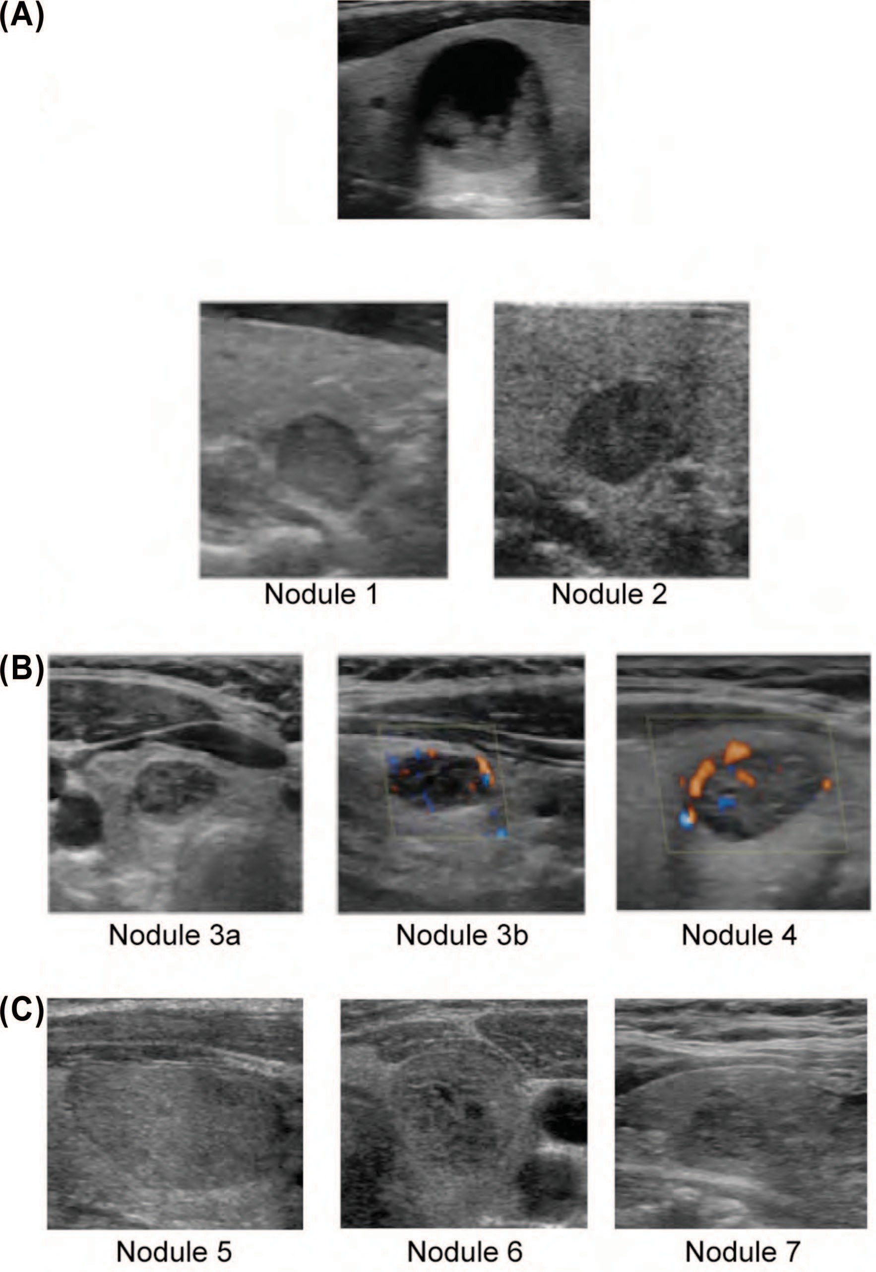

**Figure 2:** Benign US images of thyroid nodule: (**A**) cystis (**B**) hypoechogenic nodules (**C**) isoechogenic nodules (Data acquired and used in (14) and (17)).

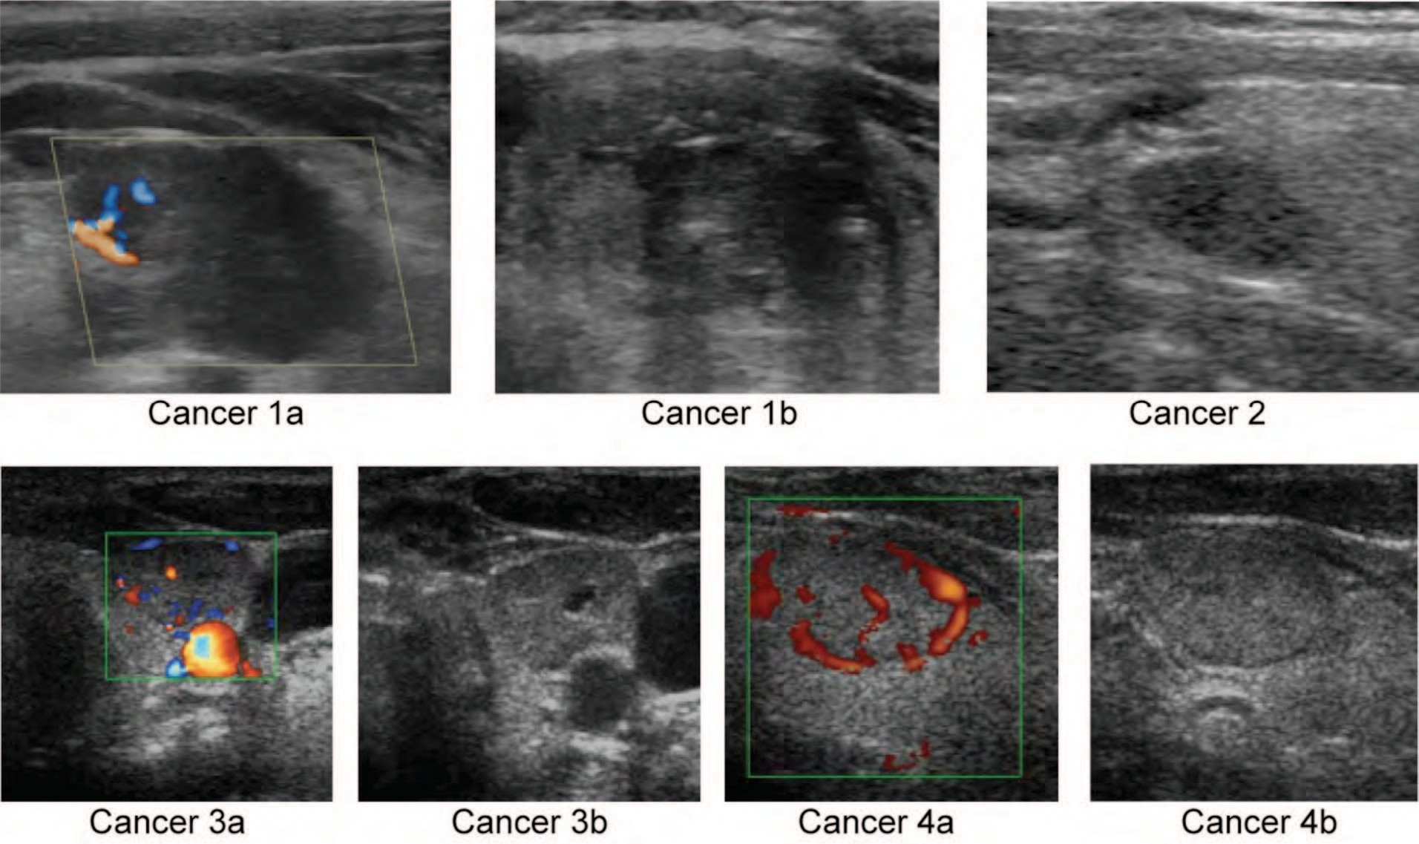

**Figure 3:** Malignant US images of thyroid nodule (Data acquired and used in (14) and (17)).

images of thyroid cancer affected nodules contain echo- graphic patterns like microcalcifications, hypoechogenicity compared to the surrounding parenchyma, and intranodu- lar vascularization (13). The echographic patterns for both benign and malignant nodules are found to be different for the HRUS images.

*CEUS Data Acquisition*

Molinari *et al.* (14) summarized the CEUS technique, which was based on the injection of 2.5 mL of ultrasound contrast agent, followed by a 3-D imaging of the entire lesion. Operat- ing probe frequency was of the order of about 10 MHz. CEUS images of thyroid cancer affected nodules show predominant ring enhancement for benign lesions and heterogeneous enhancement in malignant lesions (15). For benign lesions, vascularization is mostly peripheral resulting in enhancement at the border of the lesion in CEUS images. Malignant lesions have rich internal vasculature that manifests in CEUS images as rich internal enhancement in form of a vessel tree with hyperechoic appearance, which is not uniformly distributed in the lesion. Because of this, the enhancement in malignant lesions is termed as heterogeneous.

*Feature Extraction*

**Sonographic Features:** These are the features that an endo- crinologist observes in US images to detect malignancy in

thyroid nodules. A brief description of these features and the respective categories is given below (12)*.*

* **Internal content:** This parameter is the ratio of solid and cystic portions in nodule mass. Depending upon the value of this parameter, the nodule can be grouped into five categories as given by Table I below.

**Table I**

Categories of thyroid nodule based on internal content (12).

|  |  |
| --- | --- |
| Category of nodule | Description of the category |
| Solid | The nodule is more than 90% solid |
| Predominantly solid | The nodule is more than 50% solid |
| Predominantly cystic | The nodule is more than 50% cystic |
| Cystic | The nodule is more than 90% cystic |
| Spongiform | More than half of the nodule consists of small and uniform cysts, thus making the nodule look like a sponge. |

* **Shape:** The three categories based on shape are ovoid to round, taller than wide, and the irregular category.
* **Echogenicity:** The echogenicity of the thyroid nod- ule can be classified into markedly hypoechoic, hypoechoic, isoechoic and hyperechoic. Markedly hypoechoic means the echogenicity of the nodule is less than the strap muscles. Hypoechoic means the echogenicity is less than the surrounding thyroid

parenchyma, but greater than the adjacent muscle. Isoechoic implies that echogenicity is same as the thy- roid, while hyperechoic means echogenicity is higher than the thyroid.

* + **Calcifications:** Calcifications can be classified as microcalcifications, macrocalcifications, rim calcifica- tions and absence of any calcification. The size of the calcium deposit is 1 mm or less in diameter in micro- calcifications, while in macrocalcifications, it is greater than 1 mm. Calcification present around the nodule is called rim calcification.
  + **EchoTexture:** Homogeneous and heterogeneous are the two variants of echotexture.
  + **Margin:** The categories of margin are well-defined smooth, well-defined speculated and ill-defined margin.
  + **Capsule invasion:** Happened or nor happened.
  + **Halo:** Present or absent.

Based on these clinical features, radiologists classify thyroid nodules as probably benign, suspicious for malignancy and indeterminate. Sonographic features like microcalcification, an irregular or microlobulated margin, marked hypoecho- genicity, and taller than wide shape are possible indications of malignancy (16).

*Textural Features*

Examples of textural features are smoothness, coarseness and pixel regularity. Textural analysis can be done either by structural or by statistical methods. For image analysis, sta- tistical analysis methods like entropy, homogeneity, symme- try, contrast, and energy are more suitable and they are less complex (17). A brief description of different texture based features is given below.

* + **Texture features from Gray Level Co-occurrence Matrix (GLCM) (18):** GLCM is defined over an image as the distribution of co-occurring values at a given offset. The homogeneity feature determined from GLCM measures the similarity between two pix- els that are (Δ*x*, Δ*y*) apart. In general, the entropy fea- ture will have a maximum value when all elements of the co-occurrence matrix are the same.
  + **Fractal Dimension (FD):** The concept of FD origi- nates from fractal geometry. FD is a measure of the surface roughness or irregularity of images. FD is very useful for thyroid cancer diagnosis as the echographic patterns show marked differences in the images of benign and malignant thyroid nodules (19).
  + **Local Binary Pattern (LBP):** LBP, developed by Ojala *et al*. (20), presents the combination of structural and statistical features of the texture of an image.
  + **Fourier Spectrum Descriptor (FSD):** FSD quantifies changes in the contours of an image.
* **Laws Texture Energy (LTE):** This is a measure of texture energy. The energy within the pass region of the filter is estimated by applying the texture energy transforms to the image (21).

More details of FD, LBP, FSD and LTE features can be found in Acharya *et al*. (19), who used these features for thyroid nodule classification.

*Vascular Features*

Thyroid nodules can be studied by analyzing the vascular parameters derived from preprocessed and skeletonized 3D CEUS images. Some vascular parameters are number of vascular trees (NT), number of branching nodes (or branch- ing points) (NB), vascular density (VD), 2D vascular tor- tuosity (DM), mean vessel radius (MR), and 3D vascular tortuosity (SOAM) and inflection count metric (ICM). More details about the vascular parameters are given in Molinari *et al*. (14).

*Discrete Wavelet Transform (DWT) Features*

The minute variability present in the gray levels of malignant and benign images can be deciphered using DWT features. Acharya *et al*. (17, 22) used DWT coefficients for thyroid nodule classification.

**Classification:** Classifiers learn input observation to classify to belong to a particular class. Usually for classification tasks, supervised learning is preferred. In this type of learning, during the learning step, patterns and the class labels of benign/malignant are fed to assist the classifier train the relationship among them. After learning, unknown test pattern is fed. With the knowledge gained during the learning step, the system will classify the class of the unknown image. We summarize below the most commonly used classifiers that were used in thyroid nodule detection.

* **Gaussian Mixture Model (GMM):** GMM is a gen- eralized basic function network where the basis func- tions are Gaussian functions and are merged to provide multimodal density. During the training phase of the GMM, Expectation-Maximisation algorithm is used for tuning the GMM and its performance is evaluated using the test data (23).
* **Support Vector Machine (SVM):** SVM consists of a hyperplane or a set of hyperplanes (according to the number of classes required) in a high dimensional space. Classification is done using hyperplanes. The hyperplane is chosen such that it forms the huge sepa- ration between the two classes. In other words, the distance from the hyperplane to the nearest sample on each side is maximized. SVM maps samples as points

in a space such that samples belonging to separate classes are divided or separated by a very clear and wide gap (24).

* + **K-Nearest Neighbor (KNN):** KNN classifier is an instance based classifier where the classification of an unknown sample is performed by relating the unknown to a known sample according to some distance or simi- larity criteria (25). Here, a sample is assigned a class which is the most common among its K-nearest neigh- bors and K is a small positive number. These set of neighbours can be considered as the training samples for this classifier for which correct classification is known.
  + **Probabilistic Neural Network (PNN):** In PNN, the operations are organized in a multi-layered feedfor- ward network consisting of four layers. These are the input layer, pattern layer, summation layer, and out- put layer. Radial Basis Probabilistic Neural Network (RBPNN) is a two-layer radial basis network which can be used for classification purposes (26). The first layer (radial basis layer) evaluates the distance vector by estimating the distance between input vector and the training input vectors. The next layer (competitive layer) performs a summation of contributions for each input class and yields a vector of probabilities at its out- put. The maximum probabilities of the test data can be used by the *“compete”* transfer function to evaluate the unknown class.
  + **Decision Tree (DT) classifier:** A decision tree par- titions the training set in a recursive way, until each partition contains dominant samples from one class. DT classifier splits a complex decision-making pro- cess into simpler decisions and the output is gen- erated as a binary tree-like structure. Many rules for the various classes are evalauted from the tree, and these rules can be used to classify the unknown class (27).
  + **Adaboost classifier:** This is a meta-classifier used for the purpose of improving the performance of weak classifiers (28). This classifier uses machine learn- ing algorithm, which feeds the input training set to a weak learner algorithm repeatedly. In each of these repetitions, the algorithm maintains and updates a set of weights for the training set. The algorithm starts with keeping all weights to be of the same value. After each call, the weights are updated in such a way that the weights of incorrectly classified examples are increased.
  + **Naives Bayes Classifier (NBC):** This classifier is based on Bayes theorem and assumes that the pres- ence of a particular feature of a class is unrelated or not dependent on the presence of any other feature. Gener- ally, Naives Bayes model estimates parameters using the method of maximum likelihood (29).
* **Fuzzy Sugeno Classifier:** Here, Fuzzy Inference Sys- tem (FIS) is generated using subtractive clustering. FIS consists of a set of fuzzy rules based on which a feature space is generated during the training phase. To decide the class of test data, fuzzy inference calculations are performed (30).

The classification efficiency of the classifiers is evaluated by calculating the parameters namely accuracy, PPV, sensitiv- ity and specificity. The classifiers, which show higher value for these parameters, have higher capability and reliability in detecting the nature of the thyroid nodule.

*From Characterization to Classification: Current Results and Limitations*

Analysis of suitable features extracted out of US images is a non-invasive and affordable way of detecting thyroid malig- nancy. Many studies have used features of US images for thyroid malignancy detection. It was observed that the charac- teristics of taller-than-wide shape, marked hypoechogenicity, micro and macrocalcifications, microlobulated or irregular margin, solid pattern and intranodular vascularity, increased blood flow in nodule as indicated by Doppler, local invasion, regional lymphadenopathy and presence of multiple nodules strongly indicate malignancy (10, 31-34). Predominantly cystic nodules and cystic and spongiform nodules, having macrocalcifications larger than 1 mm in diameter or rim-like calcifications are generally benign in nature (16). Iso, hypo or hyperechoic nodules with irregular shape or a shape of ovoid to round with a margin which can be well-defined or ill-defined and having rim calcification can be classified as indeterminate (35-37).

There are a number of studies in the literature that use sono- graphic features for detecting thyroid malignancy. The limi- tation of such an analysis is the occurrence of inter- and intra-observer variability in the interpretation of results even by experienced medical experts. Park *et al*. (12) found that the inter-observer agreement was moderate for the features of shape, echogenicity and calcification while the agreement was fair for the features of margin, echotexture and capsule invasion. The average range of sensitivity, specificity, posi- tive predictive value, and negative predictive value were 65.3%-81.9%, 60.7%-68.9%, 69.7%-73.8%, and 66.6%-

75.5%, respectively. Hong *et al*. (16) found that the positive predictive values for malignancy using sonographic fea- tures of microcalcifications, microlobulated margin, marked hypoechogenecity, shape of taller than wide are 38.6%, 28.2%, 49.4% and 59.8% respectively. Table II summarizes these studies. As can be seen from Table II, there is a high variability in the ultrasound image characteristics that were used to distinguish between benign and malignant nodules. For example, Kim *et al.* (38) found that microcalcifications

***Ultrasound-based Thyroid Cancer Classification – A Review***

***297***

*Technology in Cancer Research & Treatment, Volume 13, Number 4, August 2014*

**Table II**

Summary of studies that used clinical and sonographic features to distinguish between benign and malignant thyroid nodules.

Features

Results

Echogenicity

Homogeneity

Microcalcifications

Size

Margin

Shape

Vascularity

Halo

Authors Objective and/or results obtained in predicting malignancy in thyroid nodule (Values in %)

Rago *et al.* (37) ✓ ✓ ✓ ✓ ✓ ✓ Only atypia at cytology and spot microcalcifications at thyroid ultrasound were significantly

associated with malignancy in follicular and Hurthle cell thyroid lesions cases.

Méndez *et al.* (49) ✓ ✓ ✓ ✓ ✓ ✓ Along with number of nodules, lobes and several features, this study showed that nodule border,

shape, hypoechogenicity and presence of microcalcifications were associated with malignancy.

Gul *et al.* (10) ✓ ✓ ✓ ✓ ✓ ✓ Reported that FNAB is very good in thyroid nodule classification

Jabiev *et al.* (50) ✓ ✓ ✓ ✓ ✓ ✓ Reported that hypoechogenicity, irregular borders and microcalcification were associated with

differential thyroid cancer.

Stang *et al.* (51) ✓ Reported that nuclear imaging and molecular markers can predict thyroid malignancy Park *et al.* (12) ✓ ✓ ✓ ✓ ✓ Sensitivity: 65.3-81.9; Specificity: 60.7-68.9; PPV: 69.7-73.8; Accuracy: 66.6-75.5

Henrichsen *et al.* (52) ✓ ✓ ✓ ✓ Evaluate the importance of cystic change in malignant nodules. Reported that 88% of the cancerous

thyroid nodules are uniformly solid

Kim *et al.* (38) ✓ ✓ ✓ ✓ Sex, Age, and Thyroid-stimulating hormone (TSH) were also used as features to detect malignancy

in HCN using FNA. Tumor size and Age were reported to be important

Kim *et al.* (39) ✓ ✓ Along with the additional features of Sex, Age, TSH, thyroglobulin antibody (TgAb), thyroid peroxidase antibody (TPOAb), the study reported that a positive serum TgAb test independently predicts Thyroid malignancy.

Moon *et al.* (53) ✓ ✓ ✓ ✓ ✓ ✓ ✓ Reported that neither vascularity alone nor vascularity combined with grayscale US features is useful

in detecting thyroid malignancy.

Hong *et al.* (16) ✓ ✓ ✓ ✓ Reported that microcalcifications, marked hypoechogenecity and taller than wider shape are

important features; Reported that the most reliable sonographic feature of malignancy was the taller than wide shape

Lu *et al.* (54) ✓ Sensitivity: 33.7; Specificity: 93.6; Positive likelihood ratio: 42; Negative likelihood ratio: 91.1 Lee *et al.* (55) ✓ ✓ ✓ ✓ ✓ Reported Sensitivity, Specificity, PPV and Accuracy of 86, 95, 91 and 92, respectively

Maia *et al.* (56) ✓ ✓ ✓ ✓ ✓ Along with age feature, this study reported 81.7% accuracy

Algin *et al.* (35) ✓ ✓ ✓ ✓ Reported that Pulsatility Index (PI) and Resistive Index (RI) values are useful in detecting malig-

nancy in Power Doppler US images (vascularity parameter was not found to be useful)

were important for distinguishing Hurthle Cell Neoplasms (HCN) lesions, but they were not considered when thyro- globulin antibody was used as predictor of the risk factor (39). The same variability is found when ultrasound Dop- pler parameters were considered. The majority of the studies found that nodular vascularity is linked to malignancy, but the presence of peripheral halo is still questioned (10, 35).

The relatively high variability in the echographic signs of malignant lesions and the need for better description and interpretation of the image led to the development of more and more complex classification schemes. There are many studies conducted for the classification of thyroid nodules as benign and malignant using statistical and texture based features. These studies differ in input data format, features, methods and classifiers. The purpose of such pattern recogni- tion methods is to evaluate the best computer aided system that can yield highest accuracy of classification in diagnosing benign and malignant classes. A summary of these studies follows and is also consolidated in Table III.

D’Souza *et al*. (40) used sonographic features of HRUS images and Standardized Uptake Value (SUV) (max) criteria and achieved an accuracy of only 81.5%, sensitivity of 80.8% and specificity of 81.6% when HRUS parameters alone were used. Lyshchik *et al*. (41) found that for small thyroid nod- ules, with a normalized vascular index greater than 0.14 and a diameter less than 2 cm diameter, power Doppler sono- gram combined with univariate analysis of normalized and weighted vascular indices could obtain 86.2% accuracy, 72.4% sensitivity and 100% specificity, respectively, for

benign-malignant classification. Finley *et al*. (42) used the method of molecular profiling on oligonucleotide microar- ray features to obtain accuracy, sensitivity and specificity of 93.9%, 91.7% and 96.2%, respectively. Patton *et al*. (43) obtained an overall malignancy detection accuracy of 90% by using the *in vivo* iodine content ratio of selected parts or total thyroid gland that was determined using fluorescent scanning. Cerutti *et al*. (44) used the immunohistochemistry parameter of gene expression to achieve accuracies of 90.6% with FNA and 85.2% with follicular thyroid adenomas. Hong *et al*. (45) used real-time ultrasound elastography and obtained sensitivity of 88% and specificity of 90% for thy- roid nodule classification. Ding *et al*. (46) extracted statistical and textural features from thyroid elastograms, using SVM classifier to obtain an accuracy of 93.6%.

In our previous study published in 2010 (14), we used image processing methods to the CEUS 3D volumes of malignant and benign lesions, and quantified intranodal vascularity parameters. However, in our later studies (17, 19), we devel- oped computer aided classification frameworks for the differ- ential diagnosis of thyroid lesions using statistical and texture features extracted from 3D CEUS images which can effec- tively evidence and quantify microvessels and intranodular vascularity. Acharya *et al*. (17) extracted four texture based and DWT based features from 3D CEUS thyroid images and used them in the KNN classifier to obtain an accuracy of 98.9%, sensitivity of 98% and specificity of 99.8%. Acharya *et al*. (22) used a combination of texture and DWT based features extracted from 3D HRUS thyroid nodule images in an Adaboost classifier with perceptron as weak learner to

**Table III**

Summary of studies that used non-clinical features for thyroid nodule classification.

|  |  |  |  |
| --- | --- | --- | --- |
| Authors | Features | Modality/Classification technique | Classifier performance (Values in %) |
| Patton *et al*. (43) | Iodine content ratio | Fluorescent scanning/Manual classification | Accuracy: 90 |
| Finley *et al*. (42) | Oligonucleotide microarray features | Molecular profiling/Hierarchical  clustering | Accuracy: 93.9; Sensitivity: 91.7;  Specificity: 96.2 |
| Cerutti *et al*. (44) | Immunohistochemistry parameter of  gene expression | Gene expression/Manual  classification | 90.6% accuracy with FNA, 85.2% accuracy  with follicular thyroid adenomas |
| Lyshchik *et al*. (41) | Normalized and weighted vascular indices | Power (Color) doppler/Univariate  analysis | Accuracy: 86.2; Sensitivity: 72.4;  Specificity: 100 |
| Hong *et al*. (45) | Tissue stiffness score | Real-time ultrasound elastography/  Manual classification | Sensitivity: 88; Specificity: 90 |
| D’Souza *et al*. (40) | Sonographic features, SUV (max) criteria | HRUS/SUV(max) criteria | Accuracy: 81.5; Sensitivity: 80.8;  Specificity: 81.6 |
| Ding *et al*. (46) | Statistical and textural features | Elastography/SVM | Accuracy: 93.6 |
| Acharya *et al*. (17) | Texture and DWT based features | 3D CEUS/KNN | Accuracy: 98.9; Sensitivity: 98;  Specificity: 99.8 |
| Acharya *et al*. (22) | Texture and DWT based features | 3D HRUS/Adaboost | Accuracy, Sensitivity, and Specificity  of 100% |
| Acharya *et al*. (19) | FD, LBP, FS, LTE | 3D CEUS/GMM | Accuracy: 98.1 |
| 3D HRUS/SVM and Fuzzy | Accuracy: 100 |

achieve 100% accuracy, sensitivity and specificity. In another recent study, Acharya *et al*. (19) used features of FD, LBP, FSD, and LTE (see Section 2.2.2) extracted from 3D CEUS and 3D HRUS thyroid images to obtain maximum accuracy of 98.1% (with GMM classifier) for CEUS and 100% (with SVM or Fuzzy classifier) for HRUS, respectively.

It is evident from the summaries of the related studies (Tables II and III) that different features extracted from thy- roid images obtained from different imaging modalities and the use of different classifiers result in varying accuracies. It is apparent that non-clinical features result in significantly higher classification accuracies compared to that obtained using sonographic features. The other added advantages of using nonclinical features are: (1) the features can be auto- matically extracted from the ultrasound images and quanti- fied as numerical values which can be used for automated classification; (2) there is no need for visual inspection and interpretation, and therefore, the results are more objective; and (3) such CAD systems can be written as software appli- cation at a low cost and installed in existing computers in the clinics at no extra cost. Gul *et al*. (10) found that the sensi- tivity, specificity, PPV, and accuracy of FNAB are 89.16%, 98.77%, 96.10% and 96.32%, respectively. Acharya *et al*.

1. reported that DWT and texture based features extracted out of 3D US images can result in more than 98% sensitiv- ity, specificity, PPV, and accuracy. Thus, such CAD tools result in performance that is equivalent or better than that of FNAB with the added advantages of being automated, fast, cost-effective, and non-invasive.

Finally, we would like to state that the computer-aided diag- nosis of thyroid malignancy is critical to reduce the number of unnecessary thyroid excisions. Mihai *et al*. (47) showed that the most problematic thyroid lesion is the one clas- sified as THY3 (follicular neoplasm) by FNA biopsy and about one fourths of those with THY3 classification had a thyroid carcinoma. Since these nodules often show HRUS features that correlate to malignancy, they are sent to sur- gical thyroidectomy. This means that about three fourths of the suspicious patients still undergo a surgical excision that could be avoided. Since the cost associated with the CEUS examination followed by the use of the CAD technique for malignancy detection would be markedly less than the cost of a surgical intervention, such CAD techniques can prove to be more comfortable and cost-effective to patients with suspicious nodules.

# *Conclusion*

FNAB, the gold standard to detect malignancy in thyroid nodule, is an invasive and costly test with risk factors (48). Visual analysis of ultrasound images is a subjective test resulting in inter-observer variabilities. The sonographic

features of benign and malignant are not unique and differ for different types of benign and malignant nodules. Non- clinical features like image texture based and DWT based features, on the other hand, can be automatically extracted from the ultrasound images using computer programs. These features can then be fed to classifiers, which can auto- matically label the thyroid nodule as benign or malignant. Thus, such completely automated thyroid nodule diagnosis systems can prove to be more objective, fast, and accurate. Cost reduction is also to be considered, because, according to a recent review, the relative costs associated to standard open thyroidectomy are approximately 3000 USD for the surgery and post-surgery care, 1800 USD per day for hos- pital expenses, and about 800 USD for anesthesia services (57). Conversely, the cost of the contrast agent is reduced (1 vial of 5 mL is enough for two patients and costs about 120 USD) and the thyroid sonographic examination is no more than 100 USD. In this paper, we presented a brief description of some of the sonographic and non-clinical features, and classifiers that are commonly used in thy- roid nodule classification studies. We also reviewed the techniques and accuracies of studies that used both these types of features in classifiers for thyroid nodule classifica- tion. It was observed that DWT and texture based features extracted from 3D US images resulted in high thyroid clas- sification accuracy (even as high as 100%) which is equiva- lent to FNAB performance. Thus, ultrasound based CAD thyroid nodule characterization and automated classifica- tion techniques have emerged as potential competitors to FNAB and could be used as adjunct tools to provide the physician with a second opinion on the diagnosed nodules. It must be remembered that the cost associated to thyroid FNAB is varies from 75 USD to 350 USD depending on the study source and whether or not the pathology fees are included. Also, even though complications are rare, they might include pin, bleeding, difficulty in swallowing, infections, and persistent cough.

# *Conflict of Interest*

None of the authors have any financial or personal conflict of interest that could inappropriately influence the writing or publication of this manuscript.

***References***

* 1. National Cancer Institute. Thyroid cancer. Information available at <http://www.cancer.gov/cancertopics/types/thyroid> (2013).
  2. Hayat, M. J., Howlader, N., Reichman, M. E., Edwards, B. K. Cancer statistics, trends, and multiple primary cancer analyses from the sur- veillance, epidemiology, and end results (SEER) program. *Oncologist 12*, 20-37 (2007). DOI: 10.1634/theoncologist.12-1-20
  3. Rego-Iraeta, A., Pérez-Méndez, L. F., Mantinan, B., Garcia-Mayor,

R. V. Time trends for thyroid cancer in northwestern spain: true rise in the incidence of micro and larger forms of papillary thyroid car- cinoma. *Thyroid 19*, 333-340 (2009). DOI: 10.1089/thy.2008.0210

* 1. Zhu, C., Zheng, T., Kilfoy, B. A., Han, X., Ma, S., Ba, Y., Bai, Y., Wang, R., Zhu, Y., Zhang, Y. A birth cohort analysis of the incidence of papillary thyroid cancer in the United States, 1973-2004. *Thyroid 19*, 1061-1066 (2009). DOI: 10.1089/thy.2008.0342
  2. Sipos, J. A. Advances in ultrasound for the diagnosis and manage- ment of thyroid cancer. *Thyroid 19*, 1363-1372 (2009). DOI: 10.1089/ thy.2009.1608
  3. Slough, C. M., Randolph, G. W. Workup of well-differentiated thy- roid carcinoma. *Cancer Control 13*, 99-105 (2006).
  4. Baloch, Z. W., Fleisher, S., LiVolsi, V. A., Gupta, P. K. Diagnosis of “follicular neoplasm”: a gray zone in thyroid fine-needle aspira- tion cytology. *Diagn Cytopathol 26*, 41-44 (2002). DOI: 10.1002/ dc.10043
  5. Baskin, H. J., Duick, D. S. The endocrinologists’ view of ultrasound guidelines for fine needle aspiration. *Thyroid 16*, 207-208 (2006). DOI:10.1089/thy.2006.16.207
  6. Gutman, P. D., Henry, M. Fine needle aspiration cytology of the thy- roid. *Clin Lab Med 18*, 461-482 (1998).
  7. Gul, K., Ersoy, R., Dirikoc, A., Korukluoglu, B., Ersoy, P. E., Aydin, R., Ugras, S. N., Belenli, O. K., Cakir, B. Ultrasonographic evaluation of thyroid nodules: comparison of ultrasonographic, cytological, and histopathological findings. *Endocrine 36*, 464-472 (2009). DOI: 10.1007/s12020-009-9262-3
  8. Ivanac, G., Brkljacic, B., Ivanac, K., Huzjan, R., Skreb, F., Cikara, I. Vascularisation of benign and malignant thyroid nodules: CD US evaluation. *Ultraschall Med 28*, 502-506 (2007).
  9. Park, C. S., Kim, S. H., Jung, S. L., Kang, B. J., Kim, J. Y., Choi,

J. J., Sung, M. S., Yim, H. W., Jeong, S. H. Observer variability in the sonographic evaluation of thyroid nodules. *J Clin Ultrasound 38*, 287-293 (2010). DOI: 10.1002/jcu.20689

* 1. Bastin, S., Bolland, M. J., Croxson, M. S. Role of ultrasound in the assessment of nodular thyroid disease. *J Med Imaging Radiat Oncol 53*, 177-187 (2009). DOI: 10.1111/j.1754-9485.2009.02060.x
  2. Molinari, F., Mantovani, A., Deandrea, M., Limone, P., Garberoglio, R., Suri, J. S. Characterization of single thyroid nodules by contrast- enhanced 3-D ultrasound. *Ultrasound Med Biol 36*, 1616-1625 (2010). DOI: 10.1016/j.ultrasmedbio.2010.07.011
  3. Zhang, B., Jiang, Y. X., Liu, J. B., Yang, M., Dai, Q., Zhu, Q. L., Gao,

P. Utility of contrast-enhanced ultrasound for evaluation of thyroid nodules. *Thyroid 20*, 51-57 (2010). DOI: 10.1089/thy.2009.0045

* 1. Hong, Y. J., Son, E. J., Kim, E. K., Kwak, J. Y., Hong, S. W., Chang,

H. S. Positive predictive values of sonographic features of solid thyroid nodule. *Clin Imaging 34*, 127-133 (2010). DOI: 10.1016/ j.clinimag.2008.10.034

* 1. Acharya, U. R., Faust, O., Sree, S. V., Molinari, F., Garberoglio, R., Suri, J. S. Cost-effective and non-invasive automated benign and malignant thyroid lesion classification in 3D contrast-enhanced ultrasound using combination of wavelets and textures: A class of thyroscan algorithms. *Technol Cancer Res Treat 10*, 371-380 (2011).
  2. Haralick, R. M., Shanmugam, K., Dinstein, I. H. Textural features for image classification. *IEEE T Syst Man Cy 3*, 610-621 (1973). DOI: 10.1109/TSMC.1973.4309314
  3. Acharya, U. R., Vinitha Sree, S., Krishnan, M. M., Molinari, F., Garberoglio, R., Suri, J. S. Non-invasive automated 3D thyroid lesion classification in ultrasound: a class of thyroscan systems. *Ultrasonics 52*, 508-520 (2012). DOI: 10.1016/j.ultras.2011.11.003
  4. Ojala, T., Pietikainen, M., Maenpaa, T. Multiresolution gray-scale and rotation invariant texture classification with local binary patterns. *IEEE Trans Pattern Anal Mach Intell 24*, 971-987 (2002). DOI: 10.1109/TPAMI.2002.1017623
  5. Laws, K. I. *Rapid Texture Identification. Image Processing for Missile Guidance.* San Diego, Society of Photo-Optical Instrumenta- tion Engineers (1980).
  6. Acharya, U. R., Faust, O., Sree, S. V., Molinari, F., Suri, J. S. Thyroscreen system: High resolution ultrasound thyroid image

characterization into benign and malignant classes using novel combination of texture and discrete wavelet transform. *Comput Methods Programs Biomed 107*, 233-241 (2012). DOI: 10.1016/ j.cmpb.2011.10.001

* 1. Bilmes, J. A. A gentle tutorial of the EM algorithm and its application to parameter estimation for Gaussian Mixture and Hidden Markov Models. *International Computer Science Institute* 1-13 (1998).
  2. Vapnik, V. Statistical learning theory (Adaptive and Learning Systems for Signal Processing, Communications and Control Series). John Wiley & Sons, New York (1998).
  3. Larose, D. T. KNN. In: Discovering Knowledge in Data: An Introduction to Data Mining, 1st Ed., pp. 90-106. New Jersey; Wiley Interscience (2004).
  4. Specht, D. F. Probabilistic neural networks. *J Neural Networks 3*, 109-118 (1990). DOI: 10.1016/0893-6080(90)90049-Q
  5. Larose, D. T. Decision Trees. In: Discovering Knowledge in Data: An Introduction to Data Mining, 1st Ed., pp. 108-126. New Jersey; Wiley Interscience (2004).
  6. Freund, Y., Schapire, R. E. A decision-theoretic generalization of on-line learning and an application to boosting. *J Comp Syst Sci 55*, 119-139 (1997). DOI: 10.1006/jcss.1997.1504
  7. Han, J., Kamber, M. Data Mining: Concepts and Techniques. Morgan Kaufmann (2006).
  8. Sugeno, M. Industrial Applications of fuzzy Control. Elsevier Science, New York (1985).
  9. Cappelli, C., Castellano, M., Pirola, I., Cumetti, D., Agosti, B., Gandossi, E., Agabiti Rosei, E. The predictive value of ultrasound findings in the management of thyroid nodules. *QJM 100*, 29-35 (2007). DOI: 10.1093/qjmed/hcl121
  10. Chan, B. K., Desser, T. S., McDougall, I. R., Weigel, R. J., Jeffrey,

R. B. Jr. Common and uncommon sonographic features of papillary thyroid carcinoma. *J Ultrasound Med 22*, 1083-1090 (2003).

* 1. Khoo, M. L., Asa, S. L., Witterick, I. J., Freeman, J. L. Thyroid calcification and its association with thyroid carcinoma. *Head Neck 24*, 651-655 (2002).
  2. Papini, E., Guglielmi, R., Bianchini, A., Crescenzi, A., Taccogna, S., Nardi, F., Panunzi, C., Rinaldi, R., Toscano, V., Pacella, C. M. Risk of malignancy in nonpalpable thyroid nodules: Predictive value of ultrasound and color-doppler features. *J Clin Endocrinol Metab 87*, 1941-1946 (2002).
  3. Algin, O., Algin, E., Gokalp, G., Ocakoglu, G., Erdogan, C., Saraydaroglu, O., Tuncel, E. Role of duplex power doppler ultra- sound in differentiation between malignant and benign thyroid nodules. *Korean J Radiol 11*, 594-602 (2010). DOI: 10.3348/ kjr.2010.11.6.594
  4. Jang, M., Kim, S. M., Lyou, C. Y., Choi, B. S., Choi, S. I., Kim, J. H. Differentiating benign from malignant thyroid nodules: Comparison of 2- and 3-dimensional sonography. *J Ultrasound Med 31*, 197-204 (2012).
  5. Rago, T., Di Coscio, G., Basolo, F., Scutari, M., Elisei, R., Berti, P., Miccoli, P., Romani, R., Faviana, P., Pinchera, A., Vitti, P. Combined clinical, thyroid ultrasound and cytological features help to predict thyroid malignancy in follicular and hupsilonrthle cell thyroid lesions: Results from a series of 505 consecutive patients. *Clin Endocrinol (Oxf) 66*, 13-20 (2007). DOI: 10.1111/j.1365-2265.2006.02677.x
  6. Kim, T. H., Lim, J. A., Ahn, H. Y., Lee, E. K., Min, H. S., Won Kim, K., Choi, Y. H., Park, Y. J., Park do, J., Kim, K. H., Youn, Y. K., Cho,

B. Y. Tumor size and age predict the risk of malignancy in hurthle cell neoplasm of the thyroid and can therefore guide the extent of initial thyroid surgery. *Thyroid 20*, 1229-1234 (2010). DOI: 10.1089/ thy.2009.0443

* 1. Kim, E. S., Lim, D. J., Baek, K. H., Lee, J. M., Kim, M. K., Kwon,

H. S., Song, K. H., Kang, M. I., Cha, B. Y., Lee, K. W., Son, H. Y. Thyroglobulin antibody is associated with increased cancer risk in thy- roid nodules. *Thyroid 20*, 885-891 (2010). DOI: 10.1089/thy.2009.0384

* 1. D’Souza, M. M., Marwaha, R. K., Sharma, R., Jaimini, A., Thomas, S., Singh, D., Jain, M., Bhalla, P. J., Tripathi, M., Tiwari, A., Mishra, A., Mondal, A., Tripathi, R. P. Prospective evaluation of solitary thyroid nodule on 18f-fdg pet/ct and high-resolution ultra- sonography. *Ann Nucl Med 24*, 345-355 (2010). DOI: 10.1007/ s12149-010-0357-y
  2. Lyshchik, A., Moses, R., Barnes, S. L., Higashi, T., Asato, R., Miga,

M. I., Gore, J. C., Fleischer, A. C. Quantitative analysis of tumor vas- cularity in benign and malignant solid thyroid nodules. *J Ultrasound Med 26*, 837-846 (2007).

* 1. Finley, D. J., Zhu, B., Barden, C. B., Fahey, T. J. 3rd. Discrimination of benign and malignant thyroid nodules by molecular profiling. *Ann Surg 240*, 425-436 (2004).
  2. Patton, J. A., Hollifield, J. W., Brill, A. B., Lee, G. S., Patton, D. D. Differentiation between malignant and benign solitary thyroid nodules by fluorescent scanning. *J Nucl Med 17*, 17-21 (1976).
  3. Cerutti, J. M., Delcelo, R., Amadei, M. J., Nakabashi, C., Maciel, R. M., Peterson, B., Shoemaker, J., Riggins, G. J. A preoperative diag- nostic test that distinguishes benign from malignant thyroid carci- noma based on gene expression. *J Clin Invest 113*, 1234-1242 (2004). DOI: 10.1172/JCI19617
  4. Hong, Y., Liu, X., Li, Z., Zhang, X., Chen, M., Luo, Z. Real-time ultrasound elastography in the differential diagnosis of benign and malignant thyroid nodules. *J Ultrasound Med 28*, 861-867 (2009).
  5. Ding, J., Cheng, H., Ning, C., Huang, J., Zhang,Y. Quantitative mea- surement for thyroid cancer characterization based on elastography. *J Ultrasound Med 30*, 1259-1266 (2011).
  6. Mihai, R., Parker, A. J., Roskell, D., Sadler, G. P. One in four patients with follicular thyroid cytology (thy3) has a thyroid carcinoma. *Thyroid 19*, 33-37 (2009). DOI: 10.1089/thy.2008.0200
  7. Iannuccilli, J. D., Cronan, J. J., Monchik, J. M. Risk for malignancy of thyroid nodules as assessed by sonographic criteria: the need for biopsy. *J Ultrasound Med 23*, 1455-1464 (2004).
  8. Méndez, W., Rodgers, S. E., Lew, J. I., Montano, R., Solórzano, C. C. Role of surgeon-performed ultrasound in predicting malignancy in patients with indeterminate thyroid nodules. *Ann Surg Oncol 15*, 2487-2492 (2008). DOI: 10.1245/s10434-008-0052-6
  9. Jabiev, A. A., Ikeda, M. H., Reis, I. M., Solorzano, C. C., Lew, J. I. Surgeon-performed ultrasound can predict differentiated thyroid cancer in patients with solitary thyroid nodules. *Ann Surg Oncol 16*, 3140-3145 (2009). DOI: 10.1245/s10434-009-0652-9
  10. Stang, M. T., Carty, S. E. Recent developments in predicting thy- roid malignancy. *Curr Opin Oncol 21*, 11-17 (2009). DOI: 10.1097/ CCO.0b013e32831db2af
  11. Henrichsen, T. L., Reading, C. C., Charboneau, J. W., Donovan, D. J., Sebo, T. J., Hay, I. D. Cystic change in thyroid carcinoma: Prevalence and estimated volume in 360 carcinomas. *J Clin Ultrasound 38*, 361-366 (2010). DOI: 10.1002/jcu.20714
  12. Moon, H. J., Kwak, J. Y., Kim, M. J., Son, E. J., Kim, E. K. Can vascularity at power doppler us help predict thyroid malignancy? *Radiology 255*, 260-269 (2010). DOI: 10.1148/radiol.09091284
  13. Lu, Z., Mu, Y., Zhu, H., Luo, Y., Kong, Q., Dou, J., Lu, J. Clini- cal value of using ultrasound to assess calcification patterns in thyroid nodules. *World J Surg 35*, 122-127 (2011). DOI: 10.1007/ s00268-010-0827-3
  14. Lee, Y. H., Kim, D. W., In, H. S., Park, J. S., Kim, S. H., Eom, J. W., Kim, B., Lee, E. J., Rho, M. H. Differentiation between benign and malignant solid thyroid nodules using an us classification system. *Korean J Radiol 12*, 559-567 (2011). DOI: 10.3348/kjr.2011.12.5.559
  15. Maia, F. F., Matos, P. S., Silva, B. P., Pallone, A. T., Pavin, E. J., Vassallo, J., Zantut-Wittmann, D. E. Role of ultrasound, clinical and scintigraphyc parameters to predict malignancy in thyroid nodule. *Head Neck Oncol 3*, 17 (2011). DOI: 10.1186/1758-3284-3-17
  16. Broome, J. T., Pomeroy, S., Solorzano, C. C. Expense of robotic thyroidectomy a cost analysis at a single institution. *Arch Surg 147*, 1102-1106 (2012). DOI: 10.1001/archsurg.2012.1870

*Received: January 7, 2013; Revised: August 20, 2013;*

*Accepted: September 10, 2013*